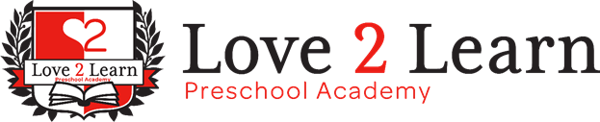

October 2020 Newsletter

# Welcome Back!

With the return of modified in-person learning, we know that many parents still have questions about school schedules, transportation, and digital learning. You are not alone! We have been working with our families to provide a smooth transition this school year. We keep communication with all 13 schools that we provide transportation to and communication with parents. We know that the decision to send your child to school is a difficult one during these times. We are providing as many options for our families as possible.

* You may choose to send your child back to school full time, we are able to provide transportation to 13 schools in our area to help accommodate parents' work schedules.
* You may choose to do a modified return to school, which includes a combination of in-person and digital learning. We will provide transportation on designated days and have them in our Distance Learning program for the other days of school.
* You may choose to continue digital learning for your child, in which we can provide the Distance Learning classroom.

If you would like more information about transportation, or our Distance Learning program, please contact the office. We want to make sure that we can be as accommodating to our families and hopefully help make this school year successful for everyone.

|  |  |
| --- | --- |
| **Enrollments**  We are currently enrolling! If you know someone in need of childcare refer them to us! We have a great referral program for our families. | **COVID UPDATE**    At Love 2 Learn we follow all Maricopa County Health guidelines for Covid-19. Plus we have our school sanitized once a week by A1 Sanitize. We want to ensure the health of all our children and staff. |

THIS Month’s

**TEACHER FEATURE**

Mrs. Bianca -Infants 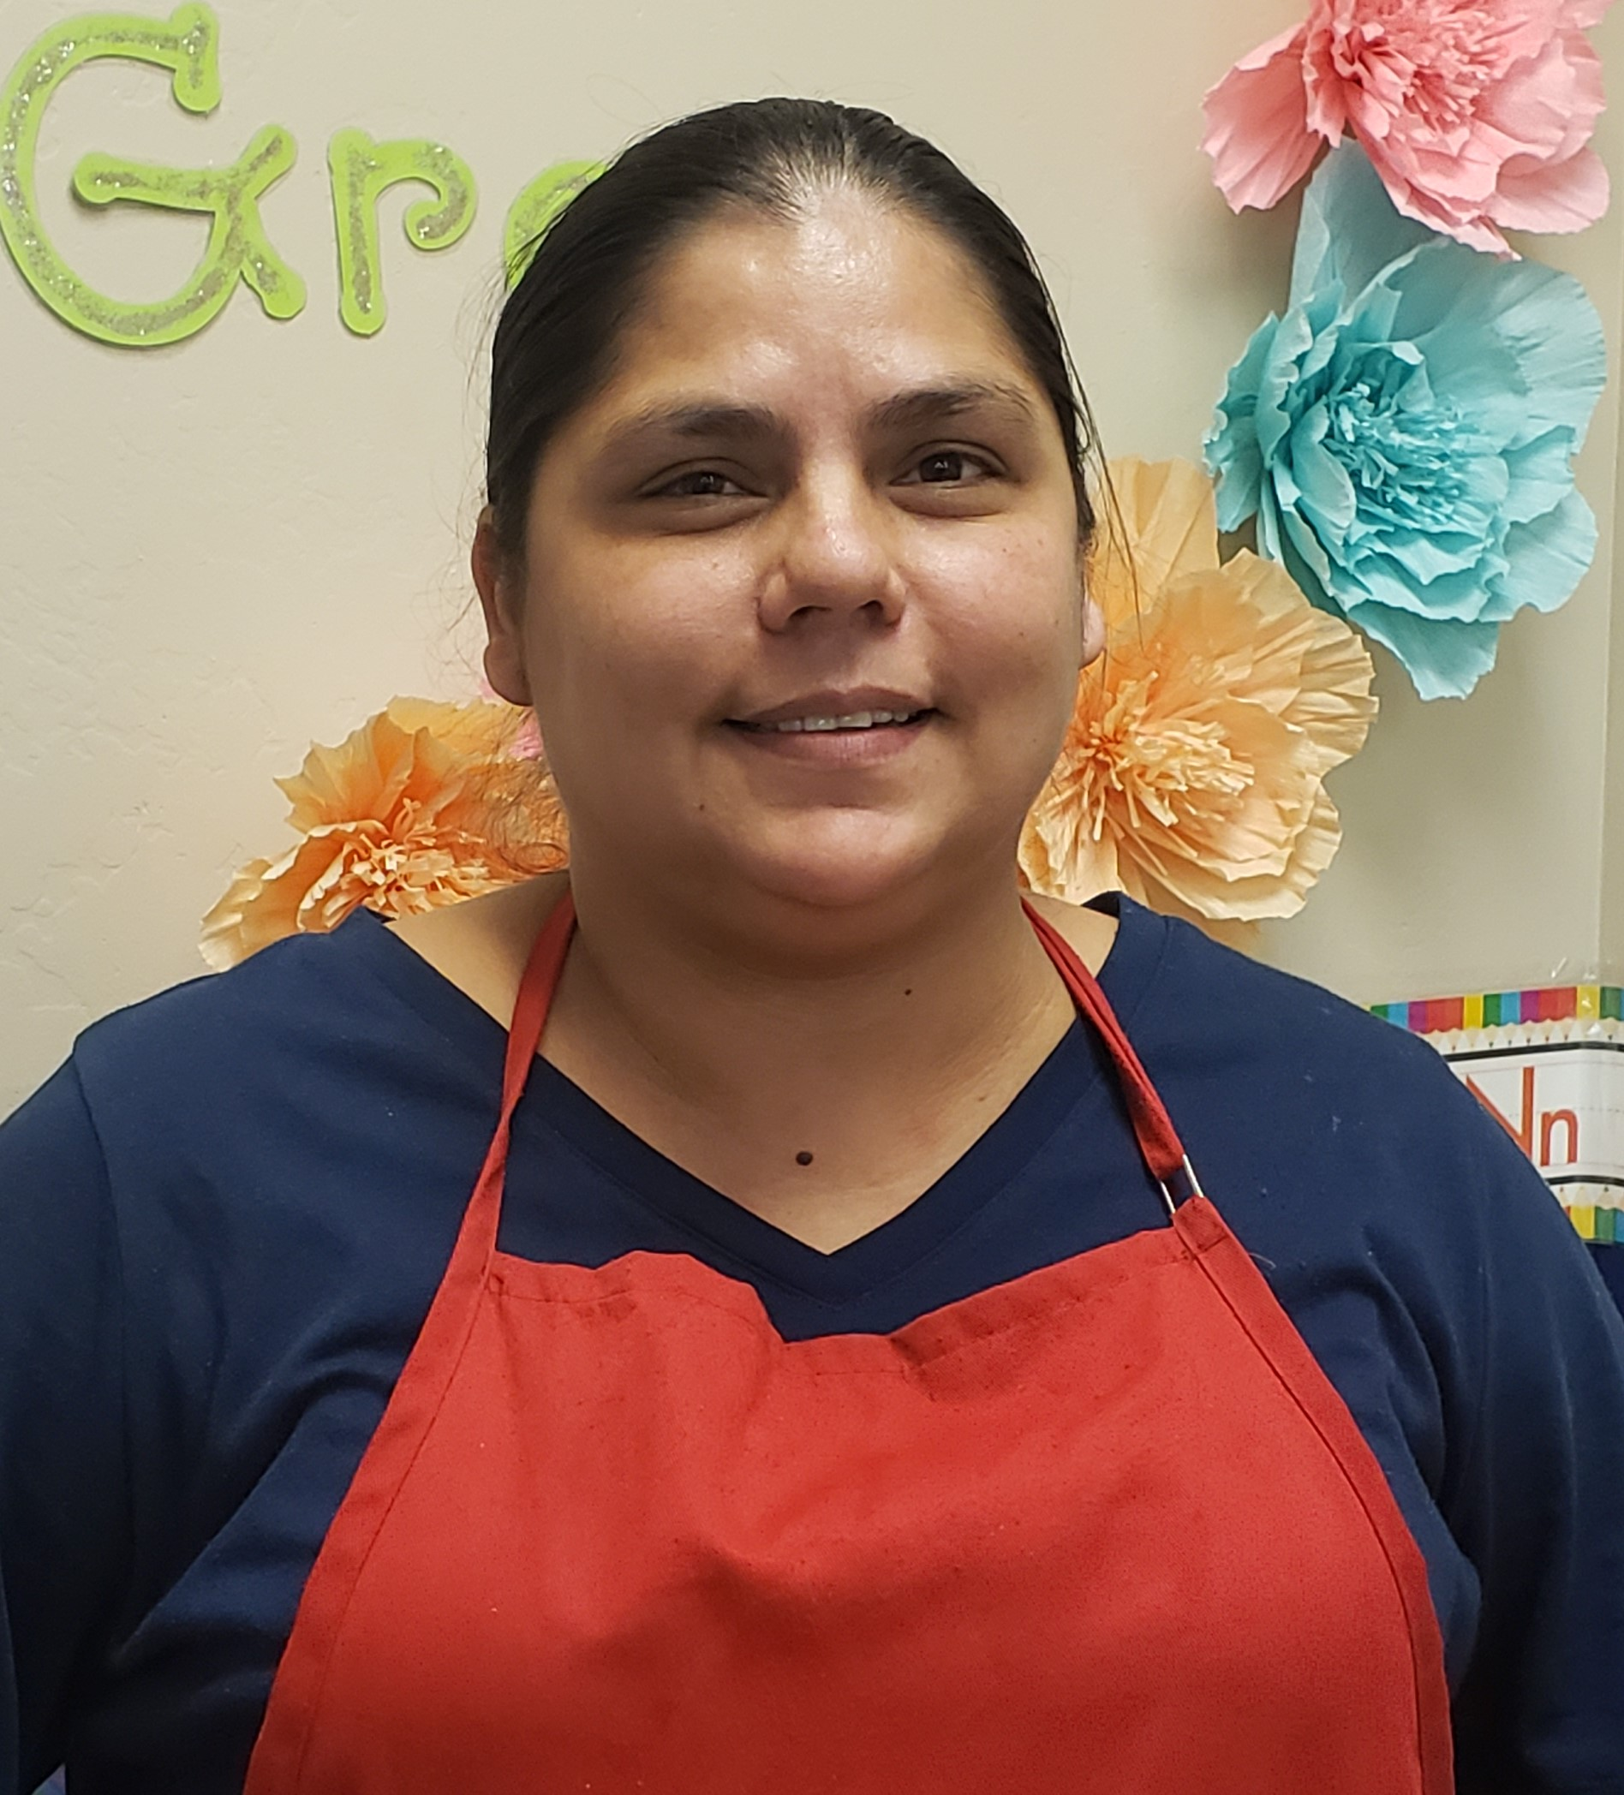

Mrs. Bianca adores working with the infants, she has so much love to give them and they are so happy to receive it. Mrs. Bianca has 3 years of experience with Love 2 Learn preschool. She provides an infant curriculum that incorporates teaching Spanish and Sign Language. She is Quality First trained through First things First and is currently participating in their Journey Through Books program to help engage our young infants in reading. Mrs. Bianca is a staple to our Infant Program and we are so lucky to have her.

## Fall Celebrations

It’s that time of year again when fall celebrations begin! There is so much uncertainty about how anyone will be able to celebrate this season, but rest assured that we will be celebrating here!

We are inviting children to dress in their costumes and they will be trick or treating classroom to classroom for treats! We will also be making Halloween treats to bring home!

|  |  |
| --- | --- |
| October Birthdays  Ari 10/1 Ryder 10/31  Jackson 10/13 Knecole 10/31  Oliver 10/14  Avrianna 10/22  Esperanza 10/26  Zaleigh 10/30 | October Calendar:  2 - Silly socks Day  9 - Backwards Day  16- Crazy Hair Day  23- Favorite Hat Day  30- Costume Day, Trick or Treat Celebration |